**Project Portfolio**

Purpose was to create a way to promote myself and boost my career for becoming a designer working on digital services.

**Project started with quick ideation of:**

Why should this portfolio exist?

* I should be able to promote myself and present my skill set and experience.
* I should also be able to stand out from the rest of the available workforce to land a position in UX design
* This is also a personal project for me to enhance my skills with design tools (adobe XD and Sketch) an web development (HTML and CSS)

Who is going to read it and why?

* Portfolio is aimed towards recruiters and possible employers
* Portfolio should act as permanent resume that presents my skills and enthusiasm

Where and how is it going to be viewed (mobile or desktop, quickly or with time)

* Portfolio -site should be something that can be scanned through quickly, and still get an idea who am I, what am I offering and what is this portfolio for.
* It should be usable on mobile and desktop, because of the wide range of possible use cases.

What content should it have?

* Portfolio –site should have more than just my portfolio.
* If I am creating a site, just for promoting me, it should also have some information about me, and not just the projects I have being involved in.

What should it look like?

* Photography is one of my hobbies, so why not take the look and feel from the photographs I have taken.
* Color scheme seems to be quite similar for all the photos I take and edit; Desaturated and moody photographs, from the streets and people.

Where should the portfolio be (pdf or web)?

* It should definitely be on the web.
* Designed and developed by me, for it to promote my skill level on design and web development (HTML and CSS)
* Benefit for web-based portfolio, is also the possibility to update it whenever I please. That way employers can find it easily and are always getting the latest version.

**Project continued with quick sketching with pen and paper:**

I quickly sketched out how the site could be used and how it should be structured:

* Every page should have a continuum with theme and structure
  + Hero element, main navigation and footer on every page
  + Same content elements should be used, to reduce workload and support the continuum throughout the site
* Keeping in mind my skill level in web development, the site should be clear and simple to maintain.
* The structure of the site is going to be quite simple so multilevel navigation is not needed

**After sketching, it was time to take my rough ideas to adobe XD:**

Visuals for the site were not implemented in the beginning:

* Purpose was to design a structure and user flow for the site, while getting more familiar with adobe XD
* Final visuals and colors were meant to design and implement later, as I was not completely sure what should they be. Also for this project, colors and images are easy to decide and adjust later on.

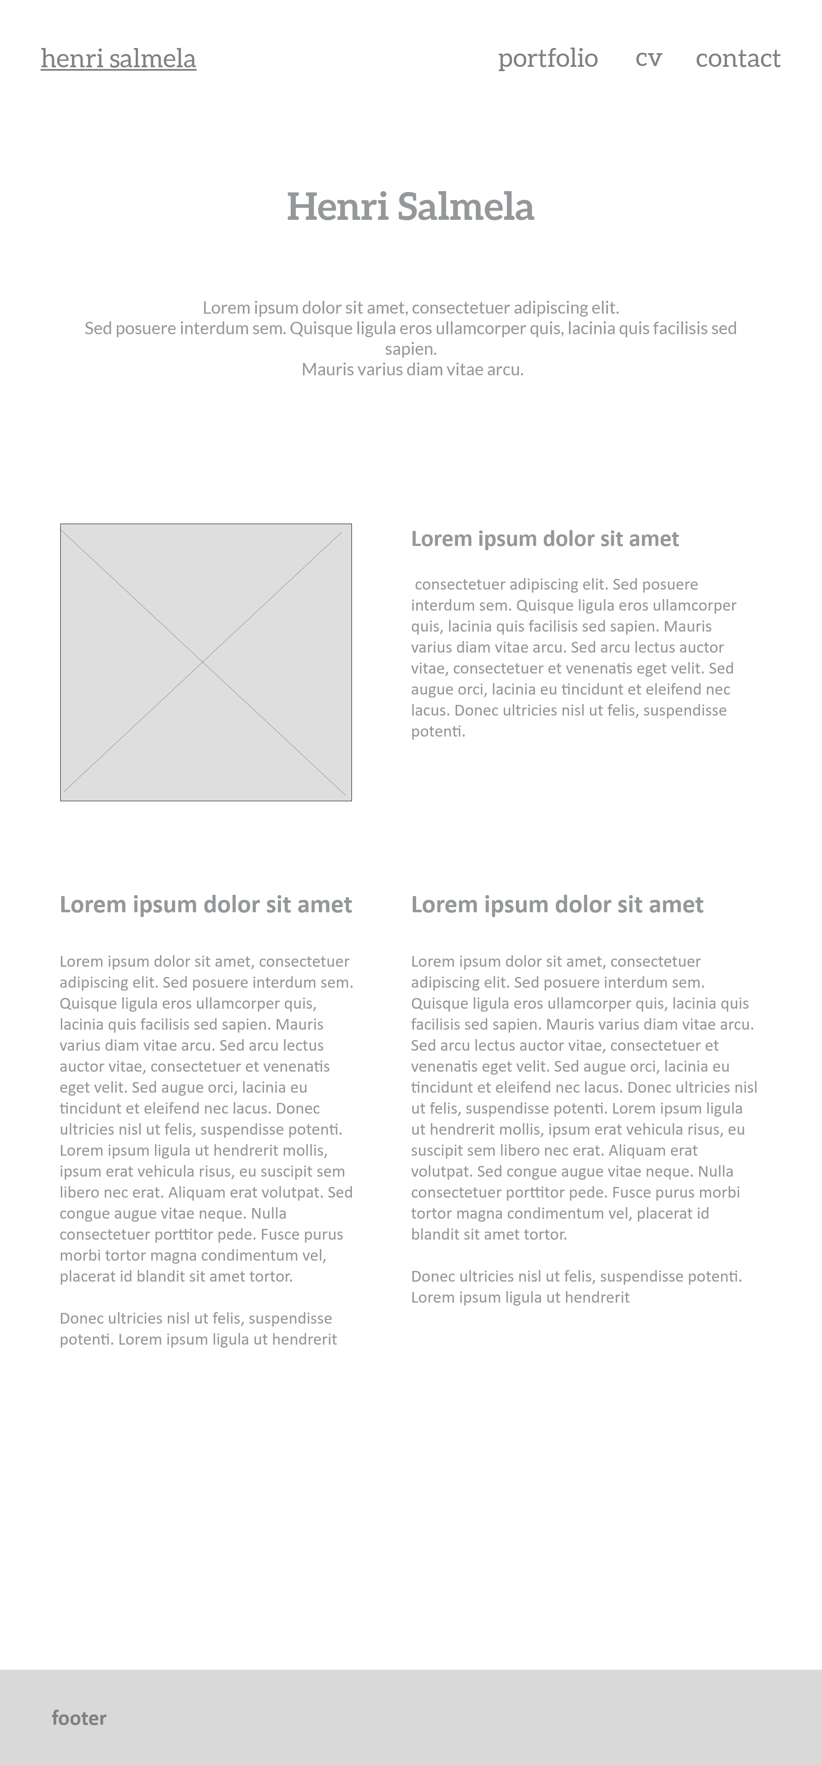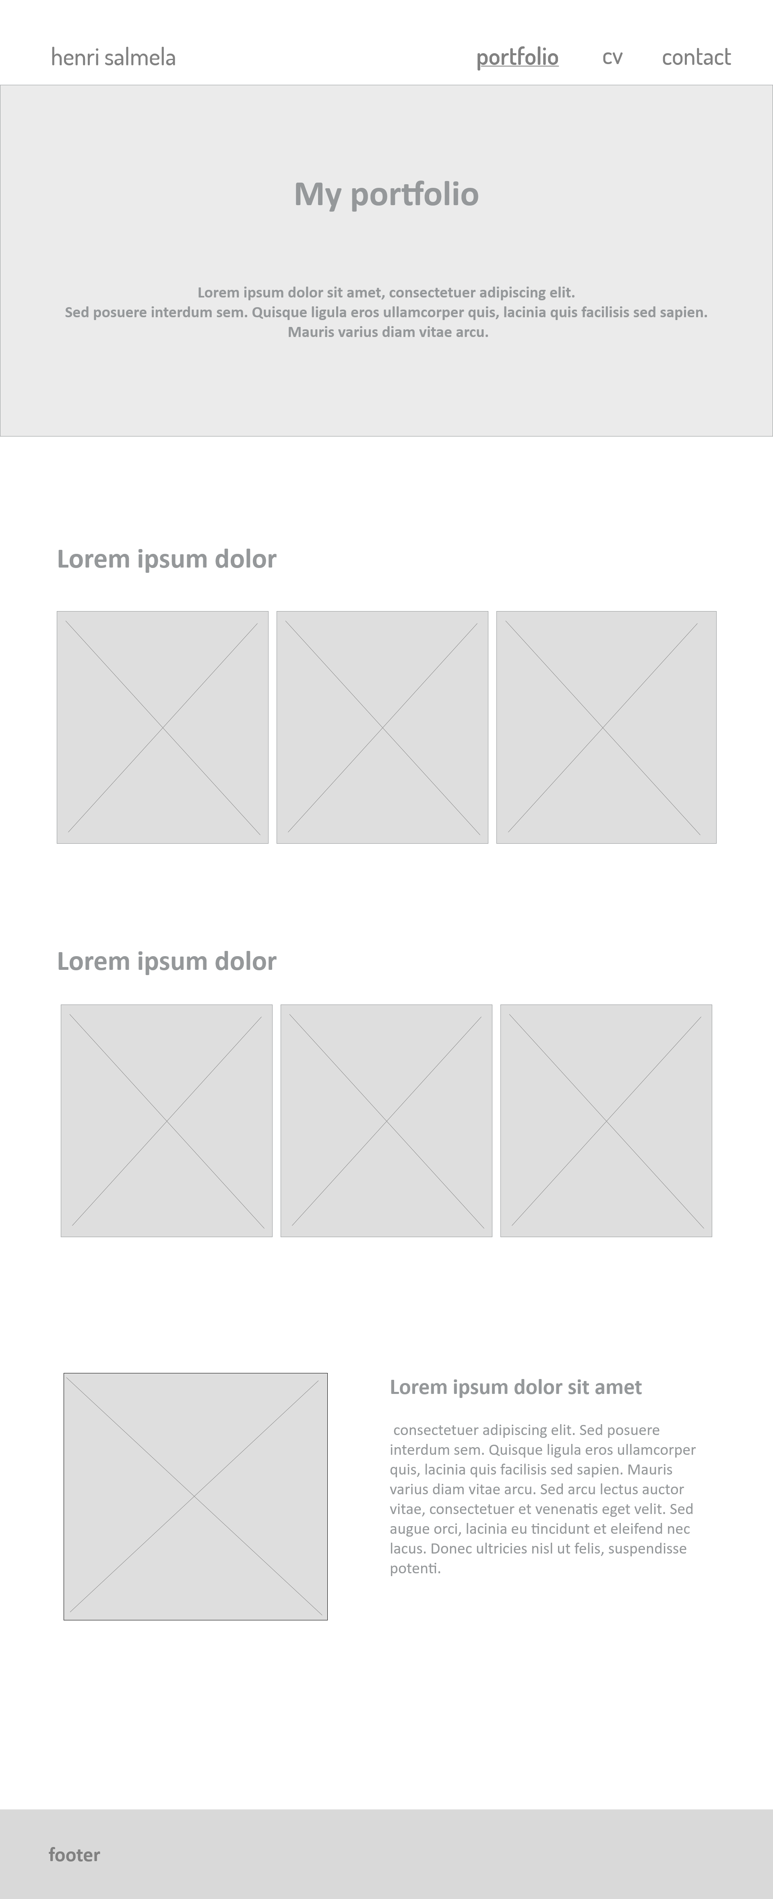

**I started development, when I was pleased with the wireframes:**

I have some experience with HTML and CSS so the start of the project went smoothly.

* As I designed the site my development skill level in mind, there were no surprises or blockers in the development.
* Images and colors were chosen during development, and I am pleased how they came out, and represent myself and my photography.

